Project-Based Learning
The Micro House

A cross-curricular unit of integration

David Watson
Former teacher: TVDSB and Western University - Faculty of Education
The Big Ideas behind ‘The Micro House Project’

As teachers, we ‘collect’ a wide range of curriculum documents. Expectation lists exist in this form simply as managerial, yet in practice, our ideal mode of delivery would be one of integration. As students build new idea, ‘boundaries’ of curriculum merge; the ‘packages’ of skills and concepts from a wide range subjects become interdependent. Applying mathematical ideas becomes the answer to: “Why are we learning this?” STEM (Science, Technologies, Engineering, Mathematics) is a planning vehicle that stitches skills and concepts together for coherent experiences. (‘STE(A)M’, initiated by TVDSB, adds an interesting ‘arts’ element into this planning.)

Optimal educational experiences take learners past simplistic exposure to new concepts and ideas into ownership as higher-ordered thinking skills (HOTS) – application, synthesis and evaluation.

The Micro House Project is an adaptable unit of work that applies skill/concept sets through the four phases developed for Smarter Science (http://smarterscience.youthscience.ca/)
Try to think of a ‘unit of work’ as a roadway on which there is breadth to alter the path.

Unit Stages

- Initiate and Plan - set a focus for the unit that allows the student to identify the key issues at their level of understanding to reduce energy consumption. So that we set the learner up for success, a series of pre-requisite Mathematics and Science concepts are included in this framework. These are listed below and suggested whole group/small group investigations can be found in the appendices.
- Perform and Record – in 1:1 scale, design the Micro House. Make technical drawings of your house on grid paper showing top / side / front views. (orthographic drawings) Show all measurements (cm or mm).
Now build the Micro House in 2:1 scale using JINX techniques. Accuracy is critical. Cover ‘outside’ surface frames, insulate and apply any finishes.
- Analyze and Interpret – test the structure for heat loss using a small heat source, while measuring the interior temperature at fixed intervals. Measure surface area and volume of building exposed to the exterior elements
- Communicate – Reflect through report writing and whole group presentation how the design and final results coincide with energy consumption in home heating. Compare effects of house area and volume impact energy usage.

Pre-requisites for this Framework: (Note: Apply as to the needs of your learners.)

 | Skills / Concepts | Appendix
S – ciences | Energy – There’s no such thing as ‘COLD’. (Before classes, students must prove this statement to be true.)  Energy – Heat on the move (dynamic equilibrium)  Energy / Structure – Its key effects on matter | S1  S2  S3
T – echnology | Energy – Using the key effect to advantage – Make the thermometer | T1
E – ngineering | Energy / Structure / Data Management – Heating a home … sources of heat / keeping the ‘heat in for the winter’ or ‘heat out for the summer (student-generated survey)  Structure – Basic JINX construction | E1  E2
A – rts | Design – Place windows and doors to demonstrate symmetrical and asymmetrical appearances  Design – Make more complex polyhedrons by combining two or more basic shapes while maintaining balance (small group task)  Design – Use colour and texture to create pleasing home surfaces | A1  A2  A3
M – athematics | Geometry – understanding the rotation of intersecting lines creating angles and associated measure  Measurement – of dimensional space including 1D perimeter / 2D surface area / 3D volume  Measurement – Calculation of Perimeter, Area and Volume of Polyhedrons  Geometry – mapping 3D shapes as orthographic | M1  M2  M3  M4
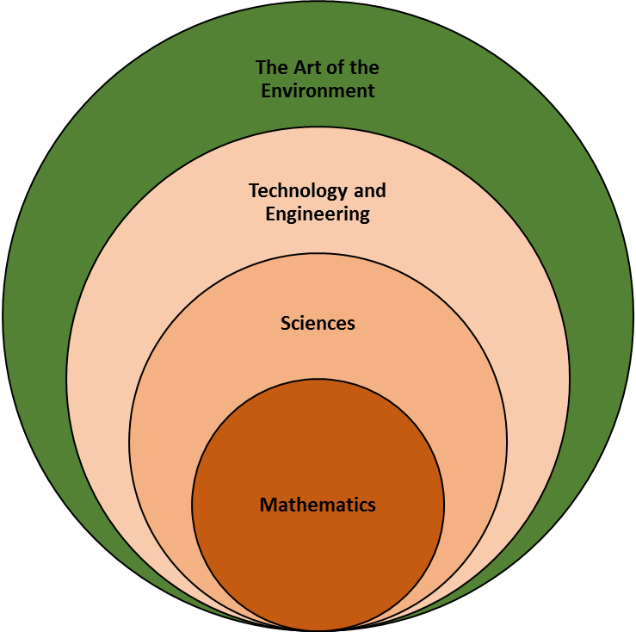
While ‘STEAM’ is an appropriate framework, keep in mind that the drivers of comprehension are somewhat different. Consider the toolkit of mathematical skills and concepts; these lie at the centre of sciences which in turn allow us to better understand key technological and engineering ideas as we apply these in our environment with great consideration to function. It’s not so much ‘Mathematics, Science and Technology’; it’s ‘Mathematics in Science in Technology’.
Consider how Steve Jobbs has designed Apple products. The art of design pulls together interaction of people with products to better function in real time. Products have to be designed effectively to fade into the background behind function. Something as simple as the curve at the corner of an iPhone changes the ordinary into the extraordinary.

Part A: Background and Introduction - Minds On!

- Global Warming …. Climate Change …. Our students frequently hear of these important issues, but they remain abstract and disconnected. To set a focus, it would benefit students to form a realistic context.
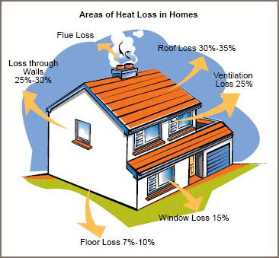
- In this unit of project-based learning, the intent stems from our basic need to heat our dwellings during winter months. The success of the venture needs to establish two core ideas. The first concept builds on the idea that there is really no such thing as ‘COLD’. Our language can get in the way here – when we say something is ‘cold’, we’re really saying that it just has less heat. ‘Cool’ water has less heat than warm water which has less heat than hot water. The second concept to understand is that heat moves from ‘where it is’ to ‘where it isn’t’. In the winter months, it would be a wonderful $ saving if we heated the house to the desired temperature and turned the furnace off for the balance of the season. (… good for the environment too) Alas, the furnace keeps coming on/off in an endless cycle.
- In the diagram to the left, heat loss can be illustrated in several forms.

- In the last step for the introduction, use widely available resources to establish the need to design and build structures that have a facility to generate heat (a variety of choices), but more importantly, to maximize the ability of the structure to keep the heat in. Vocabulary might include insulation, and possible fuel sources. (Government Resources abound but investigate energy suppliers and insulation manufacturers too.)

Teacher Notes:
In small group or individual format, students design a survey, gather and analyze data. Determine how homes (and apartments) are heated in their areas. Make the data sample set as large as possible.

In urban areas, this is most likely natural gas. Secondly, determine how structures are designed to keep the heat in during winter months. Inclusion of sketches to show the following would be helpful: gas meter, weather stripping, thermal windows with 2 or more layers of sealed glass)

Part B: The Design
- Provide each design team with a large sheet of chart paper. Grid paper (cm²) would serve this purpose best.
- At least three views are sketched: front, side and top but more may be included. These are flat two-dimensional ‘technical’ drawings known as orthographic.
- In 1:1 scale, design the Micro House on grid paper showing at least three views: front, side, top. Be sure to indicate to the students that the three views should fit on one page so that the size of the eventual model will remain manageable. Include all measurements (cm) for each view, as shown below.

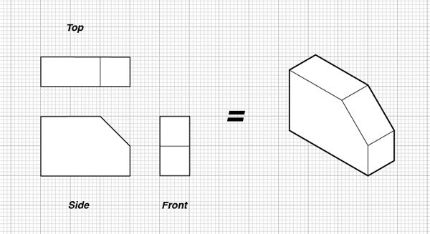
3 cm
2 cm

- Optional Extension: Take the sketch to the computer and use TABS software (ASPEX) to design the polyhedra that make up the structure of the house. At the least, there will be 2 polyhedra – a rectangular prism and a triangular prism. However, as the complexity of the structure changes, the number of polyhedra will also increase. TABS is Ontario Ministry of Education software licensed for use in all schools. Using the program allows the student to replicate the geometric shapes that will make the Micro House once assembled. The program prints out the 3D shapes as nets with the gluing TABS for easy assembly.
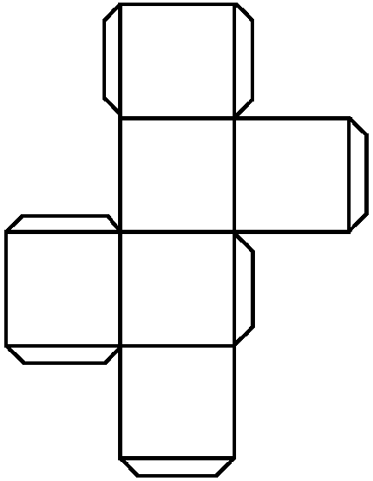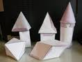
(Note: There are many CAD (computer-assisted design) programs available to do this task; however, complexity increases rapidly. A reasonable substitute might be ‘Google Sketch-Up’ which is available as a free internet download; but, there is no facility to print the nets.)
- Print the nets that will be folded into the component house parts. A plotter (if available) will allow much larger nets to be created; however, this is not necessarily required if small models will be adequate for the project.
- Your students are setting the stage to move their 2D ideas into 3D shapes, but before they do this task, have them design the exterior surfaces. Include outlines for windows and door as well as wall and roof coverings. (Older students may make actual doors / windows - plastic sheeting for windows, etc.) They should add any details before the nets are glued to cardstock, (which is simply ‘cereal box’ cardboard). Its purpose is to stiffen the nets so that the polyhedra are structurally sound. This is much easier to complete at this stage while the surface is still ‘flat on the drawing board’.

- Score the edges to be folded with scissors to facilitate straight crisp lines in the 3D shapes. Now assemble the component parts into the Micro House model. Part of the evaluation can now be completed by comparing the measurements on the grid/graph paper to the actual measurement in the finished model.
Teacher Notes:
A checklist would function efficiently to record the accuracy of the finished model
compared to the original design. Design the checklist.
Part C: The Model (functioning in 3D space)
- To start the actual Micro House, the scale is changed. For example, a 2:1 scale would mean that the dimensions of the model will be doubled when the Micro House is constructed. Change the scale to suit the available materials available to your students and their abilities.
- JINX wood is an excellent modeling material to use here; however, substitute as required. I’ve found that JINX (which is 1cm x 1cm square pine, basswood or MDF stock) is easy for the student to place on large centimeter paper for layout and measurement; the pieces are cut to length and fastened at 90⁰ (or required angle) corners to make the frame of the Micro House. Gussets made with cardstock, mass produced in right angled triangles, work well to maintain ‘square corners’. (see reference in appendix)
- Tools include small saws (at the Dollar Store) and a ‘bench hook’ to easily cut measured lengths (without damaging a desk), white or yellow glue, scissors, and rulers.
(Note: Each panel has ‘thickness’ and this will need to be kept in mind when making panels that join as well as the panel sizes needed to cover all JINX framing. Students often forget this issue and lose dimensional accuracy.)
- These panels can then be covered with cardstock on one side. These might be decorated if you wish to fit the original plan. Once the walls and ceiling areas are covered with panels, the students should investigate the effects on energy efficiency by insulating all areas (walls and ceiling or roof) representing outside surfaces.
- Whatever material is used, I restrict the students to 1 cm thickness installed within the frame members. Students have used such materials as foam, cotton batting, cloth, fiberglass and layers of newspaper for their chosen insulation, but the possibilities are wide ranging.
- Fasten the appropriate panels together to complete the Micro House.
Teacher Task:
Your checklist could function efficiently to record the accuracy of dimensions and corner angles of the Micro House compared to the original model. Extend your checklist.

Part D: The Evaluation

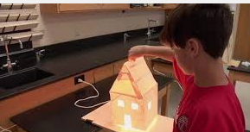


- While the teacher has already many opportunities to evaluate measurement skills as models morphed into houses, the ultimate goal is to emphasize energy efficiency. (heat retention) This is a true ‘HOTS’ opportunity (higher-ordered thinking skills).
- To prepare, several existing measurements are used to calculate:
  - surface area of the structure
  - volume of the enclosed ‘heat testing’ section. (see below)
- To test the energy efficiency of the house, place the Micro House on a surface such as a piece of plywood, large enough to test any micro house models in the class. I’ve used a Christmas tree bulb (5 watts produces adequate heat energy) fastened to the centre of the plywood, extending from below. If a low voltage (hence safer) is needed, adequate heat radiates from a 12 volt automobile bulb. In this case, a 12 volt power supply (power pack) would be needed.)
- Now the house has a ‘heat source’ which simulates the furnace.
- A thermometer is inserted into the interior of the house with the bulb of the thermometer a minimum of 10 cm away from the light bulb. Seal the house to the plywood base using masking tape to help keep heat in the house.
- When ready, the bulb is turned on.
- Measure the temperature every 30 seconds for a total time of 20 minutes to test for heat retention. Obviously the ‘better design’ will see a rise in temperature with a ‘leveling’ off temperature when the maximum temperature is reached. This is due to heat gain being equal to heat loss.
- The data is collected on a student designed table and then graphed in line format.

Note: If the student has experience with the Arduino microcontroller, lesson 2B can replace steps 5,6 and 7 above to turn the heat source on or off as inside temperature reaches set levels of heat energy. The heat source would be restricted to a 12 volt bulb since switching is needed to simulate a ‘furnace’ in an <on/off> condition.

Note: the Arduino with its lower power output would need a transistor to act like a switch and then a plug-in 12 volt power pack would light the bulb. See < https://teachmetomake.wordpress.com/how-to-use-a-transistor-as-a-switch/ ) for some helpful information.

Teacher Task:
- Students should design the charts and tables needed here - not the teacher.
- What lead information should be provided to students in advance of these designs?
- House dimensions and calculations (#2 above) should be included here.
- A graph showing heat loss is very important here. Consider the following to make these final key evaluations of the project.
Note: Understanding WHY the graph line rises and then ‘flattens out’ is critical to understanding that the Micro House is now losing as much heat as gained. This is the measurement of ‘heat-loss’. A better design will measure as a higher temperature. Record both time and temperature at this point.
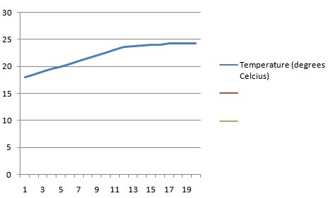
A Micro House with a higher volume will need more heat to reach this point; hence more time, but if the final point of efficiency is high, the same final temperature will be attained. The engineering will reveal quality in both design and construction.

Research Component: Conclusions for the project are made and the student groups research house design and related energy efficiency. They describe ways in which better design creates more cost effective and comfortable housing for people. This in turn could be extended into so many new directions, including costs of renovations of older homes against the need to be more efficient.

The Icicle Dilemma:
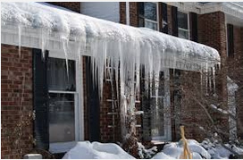
A sign that a house is not very energy efficient is a mass of ice hanging from the eaves during winter months. Identify the problems that may occur.

Teacher Notes: Using the terms ‘addition of heat’ and ‘removal of heat’, the learner’s task is to follow and explain in their terms, the sequence. (heat inside the home migrates (due to design flaws) through the attic and roof structure to melt snow, (addition if heat). The water runs down the slope over the eave. The roof here is colder (less heat) and the water loses enough heat to solidify back to a solid. As more water moves to the edge, a dam can build causing damage to the interior of the home. Solution: insulate, ventilate and seal air leaks to slow transfer of heat into the attic cavity. Keep this area cold and with dry air.)

The Micro House Project – Sample of Evaluations and Forms / Possible Alterations

Personal Records (Note: SI = student initials / TI = teacher’s initials)
# | Task | SI | TI
1 | Personal record: ‘There is no such thing as COLD’.

- Learners calculate total area of exterior surfaces and use these to extrapolate into volume measurements.
- Provide incentives to include model windows (perhaps a minimum number). Any clear plastic film.
- As number of windows, total surface area and volume increase the quality of design plays a very important role.

Appendices for the Micro House Unit

Notes:
- Choose whichever support activities that you deem are needed by your learners.
- The outlines that follow are only suggestions for components of lesson plans and can be interchanged in a variety of ways depending on resources directly available in your school and community.
- Use supplementary lesson materials readily found in classroom textbooks.
- The ideas generated will be essential to develop a clear and concise idea of heat (a measure of thermal energy) and our efficient use of this energy.

M1 – Geometry and Spatial Sense - The Angle and its Measurement
- Ask students to draw any angle in their Math workbook and then put their finger on the <angle>.
- They likely draw two lines with a common point of intersection and place a finger in the space between.


- They need to realize that one cannot touch an <angle> just as one cannot touch <time>. Both are human ideas needed to make mathematical measurements.
- An angle represents TURNING ….. How much does one line turn away from the second line with the pivot being the point of intersection?

- Pull together your usual classroom plans to designate the notion of 360 degrees for a full turn.
Have the class of children stand, face the front and guide them through a series of turns, demonstrating both clockwise and counter-clockwise turning.
Do whole group so that all learners can self-check.
Moves such as: turn clockwise 90⁰ / turn counter-clockwise 180⁰ / turn clockwise 65⁰ / etc.

- Mathematical tools to measure angles will now be required. Choose your preferred type of protractor. Consider the full circle type as the notion of turning is more prominent.
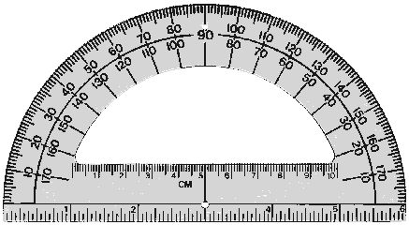
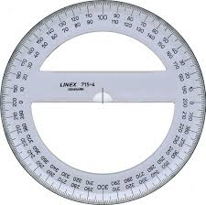

- Naming of angles and practice of constructing and classifying angles would complete the pre-requisite.

M2 – Geometry and Spatial Sense and Measurement – Dimensional Space
- While we live in 3 dimensional space (3D), most of our teaching tends to centre on single dimension (1D) as we draw lines measure distances from one point to another. These may be straight or curved lines. Learners will need to be aware that a minimum of 3 straight line segments are need to enclose a surface. Measuring <Perimeter> is a 1D measurement around the polygon.
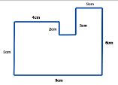
- The standardized unit is the <Metre> - (SI - system international). Relative to this are the logical sub-units all based on divisions or multiples of 10. The key issue is the revelation that any measurement can be expressed in many equivalent ways showing higher numbers as the units of measure decrease in size. (1.2 m = 12 dcm = 120 cm = 1200 mm) Patterns abound as the number of sides increases.

- Once a number of lines enclose a surface, we now have a 2 dimensional (2D) shape and we can measure it. But what do we use?
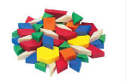
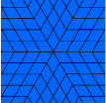
- Instead of telling learners to measure using squares, have them use pattern blocks and determine which shapes tessellate or pack together leaving no ‘gaps’. Many regular polygons will fit this result including squares, hexagons and equilateral triangles.
- Why then did we settle on <Squares>? It’s nothing more than convenience and the ease at which we can fit these into the environment we like to design with. (rooms with square corners found on floors, ceiling, windows, doors ….) They’re everywhere ….
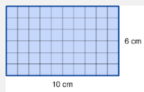
- The SI unit becomes the <Square Metre> or more correctly m² and its sub-units cm² and mm². Notice the 2 that designates square and 2 dimensions. Make models on the floor with masking tape for reference. To children a m² is ‘big space’. (Note: Actually covering large spaces (area in a gym / area on the floor / desktop) with common units such as sheets of newspaper or TP (toilet paper squares) seems to help make the connection. To measure <Area>, simply count the number of squares OR find a shortcut by letting learners show you that multiplying the length (1D – number of units long) by width gives the same value. In this example, we have 10 groups of 6 squares.
- Moving into the third dimension (3D) should be the most obvious connection but much curriculum work still tends to be rather weak here.
- As before, find shapes that tessellate in three dimensions. Many polyhedrons will satisfy this requirement but we ultimately settle on the cube. Why? ….. just convenience.
- Do have learners try it out by packing small boxes with <centicubes> or <snap cubes>.
- The volume becomes the number of cubes. As before, just count them OR find the convenient shortcut, taking the area measurement (2D) and multiplying by the 3rd dimension. AHA – 3 dimensions – <m³ > cubic metres OR V= l x w x d (3 dimensions … see the AREA formula in there too l x w )
- Notice the answer is now expressed using m³ and its sub-units cm³ and mm³. <m³ >are really big so make a class model, yet you’d be hard-pressed to make a model <mm³ >.
- Textbook practice session may be needed for your group of learners at this stage.
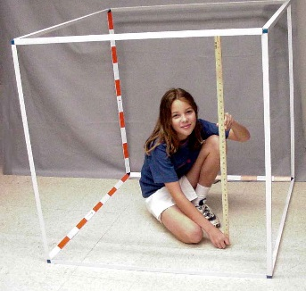

M3 - Measurement – Pulling Perimeter, Area and Volume together … Boxing Day
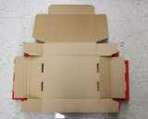
- A great practice device is the common cardboard box. Children bring in different cereal boxes, unfold and measure all 3 dimensions: lengths of sides (cm), areas of surfaces (cm²) and capacity of the box (cm³). Using markers, flood the surface with as many measurements as can be found on any face and then refold to make the 3D shape with a known volume. Unfold the box again, draw a line of symmetry on any side, cut the line and refold the box. Without recalculation, the child should experience ‘AHA’ – it’s ½ of the original volume. They’ve mastery of the idea.
- The Ultimate Exercise …. Provide a common object (tennis ball, 3 golf balls, 12 pencils, scissors) to each small group. Have them design / construct a box that is just big enough to hold the object.
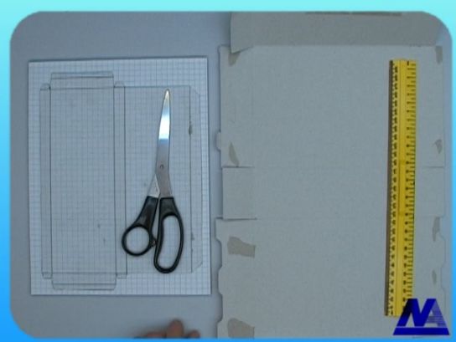
  - Design on grid paper. (here we plan a box for a pair of scissors)

  - Glue to cardstock (such as a cereal box), score the fold lines and assemble.
  - Tabs will be needed for small gluing surfaces.

  - Fold into a box and test the fit.
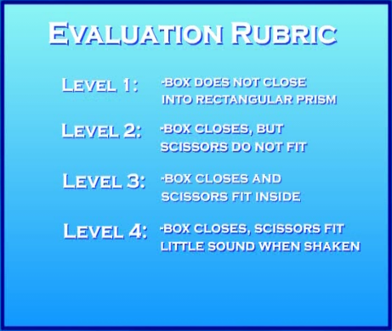
  - Evaluate the box for ‘fit’.

- Note: You might wish to use the software TABS is an excellent program to design polyhedrons and print out nets. In Ontario, this is licensed for free classroom use through OSAPAC. It is both friendly and effective. In the software, children design the 2D nets onscreen by providing dimensions. The designs are sent to the printer. While nets are in 2D, learners can draw the scale images of windows, the door and other home design details. Cut out, fold and attach the nets to make the design model of the Micro House. (Teacher Note: If this method is used, I found that the scale used here (1:1) could then be applied in a doubled ratio (2:1) when the actual JINX model was created.)
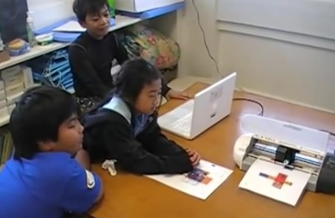
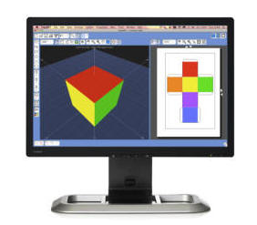

M4 - Mapping 3D shapes as Orthographic
This skill is needed as the small group of learners designs the micro house. In place of perspective drawings these are more simplistic.
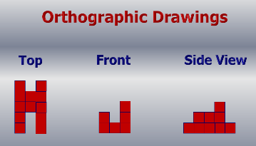
Levels 2 and 3 – Orthographic Views
- Show the drawings and build the matching polygon with snap cubes / centicubes.
- Make a polygon model with snap cubes fir learners and have them draw the 3 orthographic views on grid paper.
- Both translations for 2D 3D are important to ensure core interpretations.
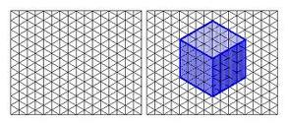
Level 4 – Add Isometric Views
- This adds a dimension (no pun intended) to orthographic mappings.
- Use isometric grid paper that is found in most teacher resource books associated with a textbook series. Lines are offset 30⁰ to create illusion of perspective.
- Isometric paper actually has an ‘up-down’ orientation.
- Use shading to build more realism into the mappings.
- The hardest drawing is the first one. Make it simplistic, such as cube.
- Now move to more complex shapes.
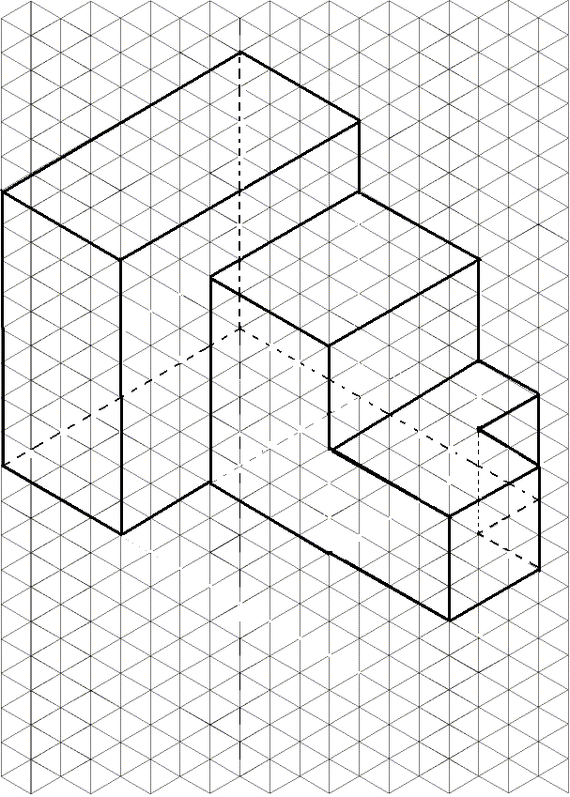

S1 – Conjecture and Proof
- This component is intended to be completed after the unit is introduced; yet, before formal lesson structures begin. Either a small group configuration or individual assignment can be used with success.

Provide each learner (or group) with 1 sheet of chart paper. Complete task on this sheet - using markers and print text in large size for display purposes next day.
Begin the planning in class and then assign the bulk of the task to be completed for the next day.
The following statement formulates the direction:

From a Scientific View, there is no such thing as ‘COLD’.

- A BANSHO (http://professionallyspeaking.oct.ca/march_2010/features/lesson_study/bansho.aspx) would be an effective vehicle to display the completed results.
There are many avenues that can be utilized effectively by learners to make their cases for the conjecture. In all situations, try to discern if the idea of ‘heat moving from where it is to where it isn’t’ appears to be merging.
Teacher Notes:
Heat is a measure of thermal energy, which is a measure of molecular activity of any substance.
A cold room just has less heat (thermal energy) than a warm room.
A refrigerator is able to remove heat from the inside and expel it to the outside of its case.
An ice cube exposed to heat changes state (solid to liquid) at 00C. Add enough heat and the state changes a second time at 1000C.
In every home (building) during winter months, heat escapes in many different ways. We replace the heat (most often) by burning fuels (natural gas, coal, oil, wood). With better design and structure, we try to minimize this heat-loss. That’s the central focus of the Micro House unit.
Why might parents say: ‘Close the door’?

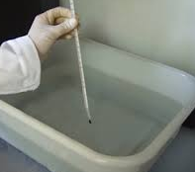
S2 – Heat: from ‘Where it is’ to ‘Where it isn’t’.
In these experiments, a ‘small group’ organization is likely ideal.
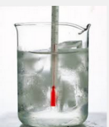
In the first instance, quantitative measurements are made; a recording chart
will be needed and a sheet of graph paper will become the end result from
which a suitable conclusion might be drawn. Use a process your learners
are familiar with as they collect and analyze data. Qualitative measurements
apply in the second investigation.

- Two containers are needed – one needs to fit inside the other.
  - The inside container is filled with an ice water / snow water mixture and the outside container has room temperature water. (Try to get volumes of water reasonably close to derive a suitable pattern on the graph.)
  - Insert a thermometer in each.
  - Record two temperatures every 30 seconds, on the data table created prior to the activity.
  - After 10 – 12 minutes, create a line graph to show the ‘story’ of temperature changes.
  - In the conclusion section of the write-up, explain using diagrams where heat has moved.

- In the second investigation, groups need two identical containers.
  - Pour the same volume of water in each. ** One container will hold ‘cold’ water (little thermal energy) and the other will hold hot water. It doesn’t need to be at the boiling point (think safety) but needs to be substantially higher than the first. Be sure containers are on a steady surface to prevent external movement and the surface is still.
  - Use an eye dropper to ‘place’ a single drop of coloured dye (food colouring) on the surface of each liquid.
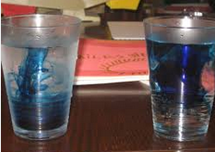
  - Make quantitative observations every 30 seconds for 5 minutes.
  - Homework: Explain the differences that you see. Use diagrams to support your descriptions.

Teacher Notes:
Water molecules move faster directly proportional to the amount of thermal energy.
Temperature is measure of the amount of thermal energy.
In this observation, the dye will ‘mix’ throughout both containers over time. However, since one has more thermal energy, it will mix faster.
The liquids mix (without mechanical stirring) due to dynamic equilibrium. The molecules are moving about
(a lot of movement = more thermal energy / less movement = less thermal energy …. not cold)
S3 – Heat: Its key effects on matter
T1 – Energy: Make the Thermometer
In these investigation, a ‘small group’ organization is likely ideal again. For each part, use whatever apparatus is available to bring the big idea that all states of matter will expand (at least a small amount) as the amount of thermal energy increases, and similarly, contract when the energy if reduces (or as we say in everyday terms, is cooled).
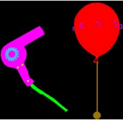
- With a gas, an inflated balloon is heated. Prior to balloon inflation, use a ruler and marker to make 2-3 lines at different places. Place cm marks along each line. Inflate the balloon, tie the end and gently apply warm air. Make observations.
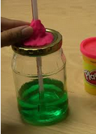
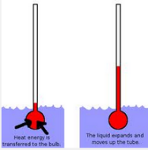
- A sealed container filled with coloured water will demonstrate the effect of added heat to a liquid. The water expands and is pushed up the straw, when the jar is held in a child’s warm hands. This is the most basic of thermometers, if a scale is added to the straw. (Teacher Notes: 1. To support the same finding as #1 above, the same apparatus may be used with no water in the jar but a drop or two place halfway up the length of the straw. 2. The liquid mixture will absorb and release thermal energy faster and with a larger volumetric change if some rubbing (isopropyl) alcohol is added.)

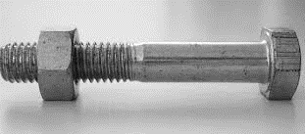
- To show the same effect with metal requires more energy; perhaps, this component is demonstrated by the teacher. A bolted is fitted with a nut (snug fit needed here ….). The bolt head is heated using a suitable source such as a stove burner or boiling water). Try turning the nut using a pair of pliers. Dip in ‘cool’ water to remove the heat and remove the nut. (Teacher Note: There are many ways to demonstrate this idea; use easily available materials.)

- Web Ideas:

  - https://www.teachervision.com/weather/lesson-plan/4131.html
  - http://www.weatherwizkids.com/experiments-thermometer.htm
  - http://www.whatdowedoallday.com/2013/07/homemade-thermometer-for-kids.html
  - http://www.energyquest.ca.gov/projects/thermometer.html

E1 – Energy / Structure / Data Management – Heating a home
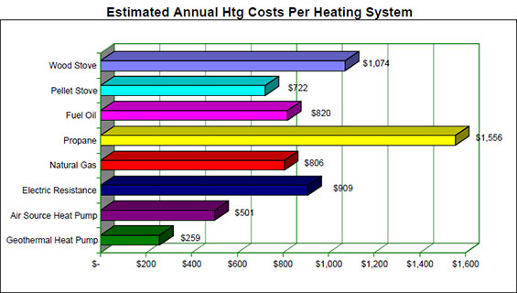
- Prior to the start of the Micro House Unit, an ideal mindset would include basic awareness of the learner’s home situation. Why does a parent often say, “Close the door” during the winter season?
- Surveys designed and carried out either individually or in small group then allow the collected data (from beyond the limits of the classroom) to be collated and analyzed. Build a bar or circle graph of the results gleaned.
- The heating source is only a small component of the big picture for the learner. Proper design of structure keeps fuel costs reasonable if heat can be kept in the structure during the months when temperatures are lower than the comfort level, and also kept out during the months when temperatures are higher than the comfort level.
- How does good design keeping the ‘heat in for the winter’ or ‘heat out for the summer?
- On chart paper, summarize the groups findings, display and present the big ideas.
- These big ideas should include:
  - Need of insulation (which slows the transfer of heat energy).
  - Elimination of air leaks in the structure using weather stripping and properly fitted windows and doors.
  - Maintain reasonable comfort levels of temperature during all seasons.
- Leave the charts available for reference during the course of the unit.

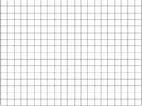
E2 – Structure: Modelling with JINX
- JINX is simple modelling material. For this unit of work, lengths of wood cut 1 cm x 1 cm square can then be placed directly on large chart paper with a cm grid pattern.
- The wood strips might be pine or very inexpensive MDF or metric plywood strips cut from cm wide. (Teacher Note: School systems don’t handle this material. While I’ve always generated materials for my students, one of the secondary schools in your area might become a source to produce JINX.)
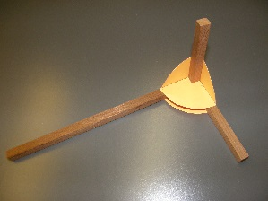
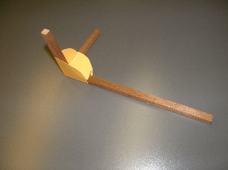
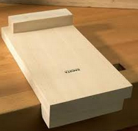
- Corners are held together using inexpensive white glue and paper (or light carstock) gussets. These need accurate 90⁰ corners and can e made using grid paper ruled with square corners. (Teacher Note: Any corners cut from manufactured paper sheet work perfectly well. My students used GOOS (photocopy) paper – ‘good on one side’ to conserve resources.)
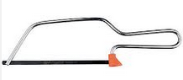
- The JINX wood needs to be measured and accurately cut to length. Use simple bench hooks prevent damage to desks and provide a firm base on which to work. Easy to make, these could be included in a class kit, along with the needed supply of JINX wood.
- The saw should be fine tooth to prevent accidents. Small saws are easily available at the ’Dollar Store’.
- Groups of learners need to practice this simple but essential skill set. Choose one of the following:
  - Build: a rectangle using 4 short lengths of JINX.
  - Build: a cube using 12 short lengths of JINX.
- Be sure to measure accuracy of completed joints and consistency of measurement
  - This simple rubric might help:
Level 4 | All corners < 1⁰ from 90⁰ / All opposide sides measure < 1 mm difference
Level 3 | All corners < 2⁰ from 90⁰ / All opposide sides measure < 2 mm difference
Level 2 | All corners < 4⁰ from 90⁰ / All opposide sides measure < 4 mm difference
Level 1 | Need refinement to continue
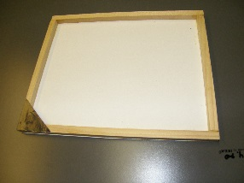
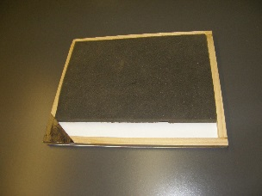
  - When panels are made for the Micro House models, use cardstock to cover the frames and then add ‘insulation’ inside the frame. Limit insulation thickness to 1 cm but choice of material is open-ended. Groups need to explore possibilities to determine best choices. In this photo, a foam packing sheet is applied for this purpose.

