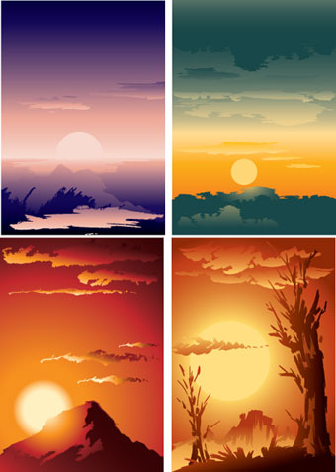
 | J  6 | J  2  1 | F  6 | F  1  8 | M  6 | M  2  1 | A  6 | A  2  1 | M  6 | M  2  1 | J  6 | J  2  1 | J  6 | J  2  1 | A  6 | A  2  1 | S  6 | S  2  1 | O  6 | O  2  1 | N  6 | N  2  1 | D  6 | D  2  1
Toronto sunrise times for 2011
date | sunrise
Jan 6 | 7:51
Jan 21 | 7:44
Feb 6 | 7:29
Feb 19 | 7:11
Mar 6 | 6:46
Mar 21 | 6:19
Apr 6 | 5:51
Apr 21 | 5:25
May 6 | 5:04
May 21 | 4:47
June 6 | 4:37
June 21 | 4:36
July 6 | 4:43
July 21 | 4:55
Aug 6 | 5:12
Aug 21 | 5:29
Sep 6 | 5:46
Sep 21 | 6:03
Oct 6 | 6:21
Oct 21 | 6:39
Nov 6 | 7:00
Nov 21 | 7:19
Dec 6 | 7:36
Dec 21 | 7:48
Jan 6 | 7:51

8:00 AM

7:00 AM

6:00 AM

5:00 AM

4:00 AM

