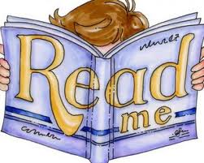
Dear Parent

Please take the time to
- read the math story Math Waves with your child
- ask your child what they learned in our class activities

Please also take the time to answer the two questions below.

Please have your child return this handout and the story.

Thank you!

What did your child share with you about their math learning?

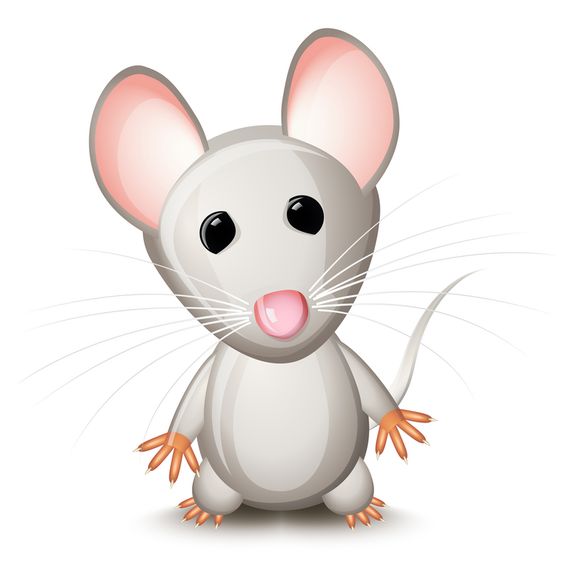
What did you learn from this math-at-home activity?

