 |  |  |  |  |  |  |  |  |  |  |  |  | height
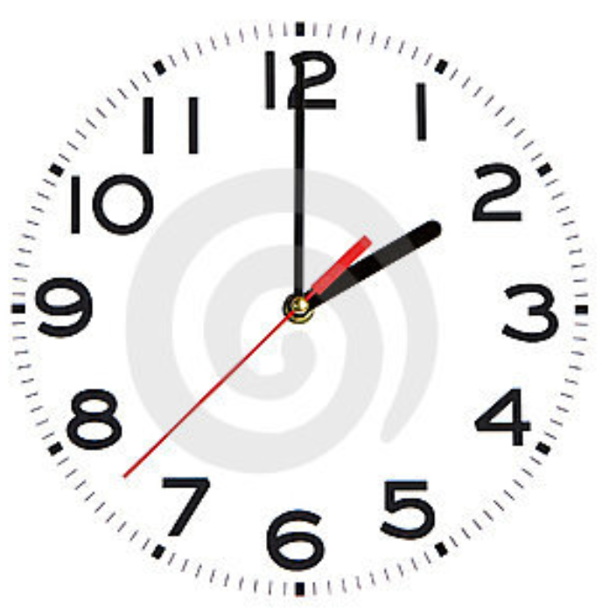
 |  |  |  |  |  |  |  |  |  |  |  |  |  |  | 
 |  |  |  |  |  |  |  |  |  |  |  |  |  |  |  | 12 1 2 3 4 5 6 7 8 9 10 11 12 1 2 3 4 5 6 7 8 9 10 11 12 1 time |  |  |  |  |  |  |  |  |  |  |  |  |  |  |  |  |  | 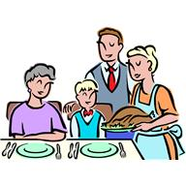
lunch time
midnight
midnight
breakfast
dinner time

