[www.researchideas.ca/wmt](http://www.researchideas.ca/wmt) 2016

**THE SUM OF HOURS ON A CLOCK**

Let's complete an addition table for hours on a 12-hour clock.

We'll use 0 for 12, so the hours we'll add will be: 0, 1, 2, 3, 4, 5, 6, 7, 8, 9, 10 and 11.

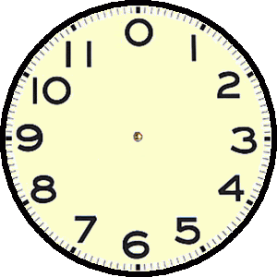

Make a prediction before you complete the table: how many different answers are possible?

|  |  |  |  |  |  |  |  |  |  |  |  |  |
| --- | --- | --- | --- | --- | --- | --- | --- | --- | --- | --- | --- | --- |
|  | 0 | 1 | 2 | 3 | 4 | 5 | 6 | 7 | 8 | 9 | 10 | 11 |
| 0 | 0 | 1 | 2 |  |  |  |  |  |  |  |  |  |
| 1 | 1 | 2 | 3 |  |  |  |  |  |  |  |  |  |
| 2 | 2 | 3 | 4 |  |  |  |  |  |  |  |  |  |
| 3 |  |  |  |  |  |  |  |  |  |  |  |  |
| 4 |  |  |  |  |  |  |  |  |  |  |  |  |
| 5 |  |  |  |  |  |  |  |  |  |  |  |  |
| 6 |  |  |  |  |  |  |  |  |  |  |  |  |
| 7 |  |  |  |  |  |  |  |  |  |  |  |  |
| 8 |  |  |  |  |  |  |  |  |  |  |  |  |
| 9 |  |  |  |  |  |  |  |  |  |  |  |  |
| 10 |  |  |  | 1 |  |  |  |  |  |  |  |  |
| 11 |  |  |  | 2 |  |  |  |  |  |  |  |  |