[www.researchideas.ca/wmt](http://www.researchideas.ca/wmt) 2016

**THE SUM OF QUARTER HOURS ON A CLOCK**

Let's complete an addition table for quarter hours on a clock.

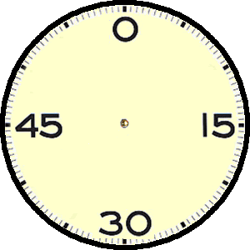

Make a prediction before you complete the table: how many different answers are possible?

|  |  |  |  |  |
| --- | --- | --- | --- | --- |
|  | 0 | 15 | 30 | 45 |
| 0 | 0 | 15 |  |  |
| 15 | 15 |  |  | 0 |
| 30 |  |  |  | 15 |
| 45 |  |  |  |  |